
Department of Education, Division of Guihulngan City
Learning Outcome Assessment (LOA)
Submission and Monitoring System

User Guide

Roles, responsibilities, and step-by-step procedures for every account type: Division Admin, School Admin, Grade Level Chairman, and Division Supervisor.

MEL E. GACHO
IT Officer I

1. Introduction
The LOA Submission and Monitoring System is a web-based platform built for the Department of Education, Division of Guihulngan City, to manage the submission and monitoring of LOA Result, Test Questionnaire, and Table of Specifications files (referred to collectively in this guide as submission files) across every school in the division. It replaces manual, paper-based tracking with a structured online workflow.
This guide is for the orientation of every user type in the system. It explains what each role is responsible for and walks through the step-by-step procedure for every major task that role performs, with screenshots of the actual system.

1.1 System Roles Overview
Role | Who Uses It | Scope of Access
Division Admin | Division office staff who administer the system | Division-wide. Manages School Admin Accounts, Division Supervisor Accounts, other Division Admin Accounts, School Year/Term/submission schedule configuration, and monitors submission status for every school. Does not upload submission files.
School Admin | The official login for a school (school head or designated staff) | One school. Manages that school's profile, organized classes/sections, Grade Level Chairman sub-accounts, uploads submission files (LOA Result, Test Questionnaire, Table of Specifications), and monitors that school's own submission status.
Grade Level Chairman | A sub-account created by a School Admin | One grade level within one school. Uploads submission files and monitors submission status for that grade level only.
Division Supervisor | Division-level subject supervisors | Division-wide, scoped by subject. Views and downloads submitted submission files (LOA Result, Test Questionnaire, Table of Specifications) for their assigned Learning Area(s) across every school. Read-only — cannot upload.

1.2 Getting Started: Logging In
Every account type signs in through the same login page. There are two ways to sign in.
1. To sign in with Google, click "Sign in with DepEd Google Account" and choose your @deped.gov.ph account.
2. To sign in with a password instead, click "Admin / Manual Login" below the Google button to reveal the email and password fields, enter your registered email and password, then click "Sign In."
3. Either way, you will be taken directly to your role's home page — the page shown depends on your account type.
4. Only accounts already added by an administrator can sign in — there is no self-registration for any role, and a personal Gmail address cannot be used with the Google option.
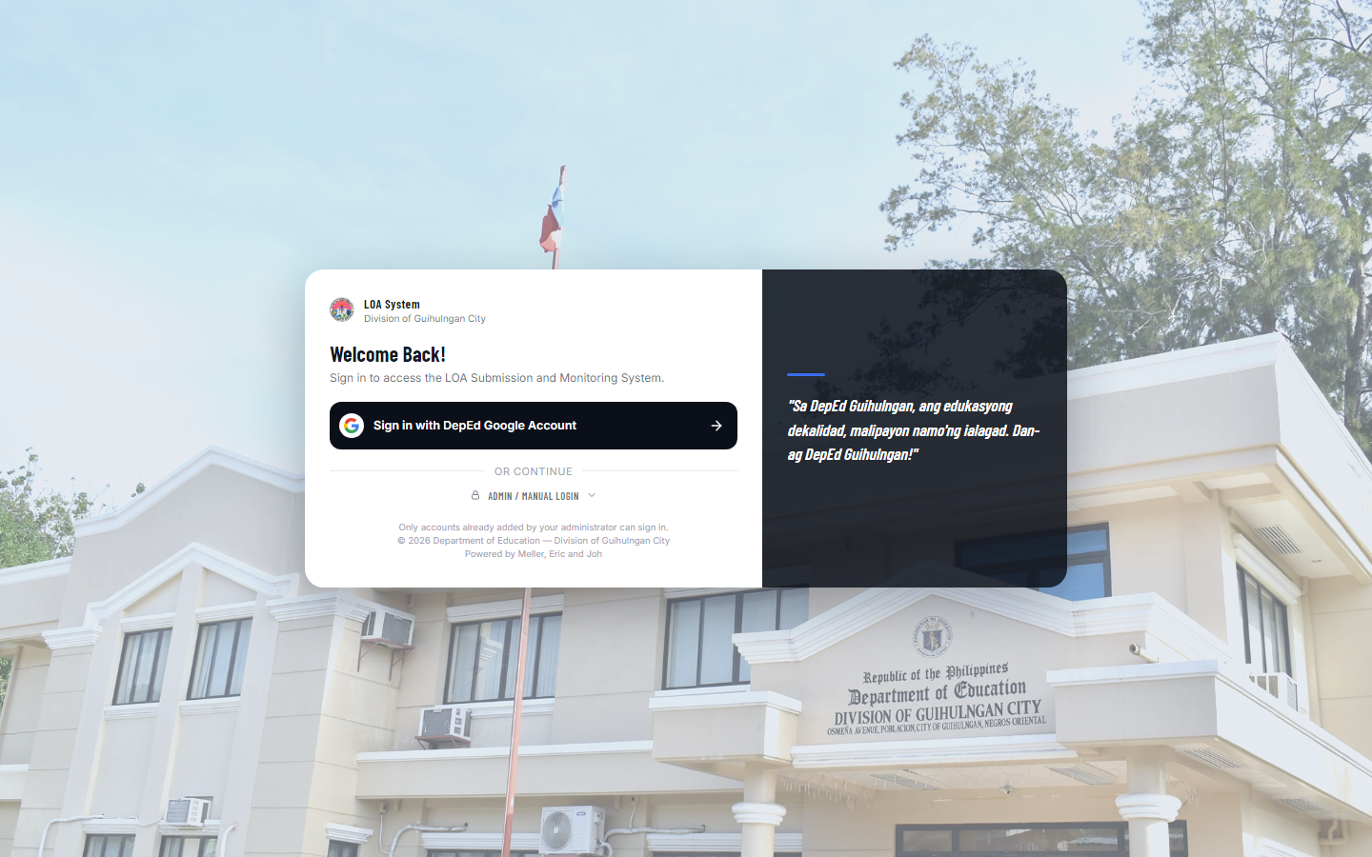
Figure 1.1 — The login page. All four account types sign in here.
If you forget your password, contact a Division Admin (or, if you are a Grade Level Chairman, your school) to have it reset — there is currently no self-service "Forgot Password" option.

1.3 Your Account Menu
Every role reaches their own Profile and Log Out from the same place: click your name/avatar at the bottom of the sidebar to open a small drop-down with two options — "[Role] Profile" and "Log Out."
- Profile lets you view/edit your account's name and email, and change your password (a School Admin's name/email are instead managed through School Profile).
- Changing your password always requires entering your current password first, for security.

1.4 Using the System on Mobile and Tablet Devices
The system is fully usable from a phone or tablet, not just a desktop browser. On a narrow screen, the sidebar is hidden by default — tap the menu icon at the top of the page to open it, then tap a menu item or tap outside the menu to close it again. Wide tables and forms scroll left-right within their own card instead of being squeezed, so nothing is cut off.

1.5 Finding Your Way: Breadcrumbs
Every page now shows a small trail near the top, just above the page title — for example, “Administration / School Admin.” It shows where you are within the menu, and every part of the trail except the current page is a link: click an earlier part to jump straight back to that section instead of using the sidebar.

2. Division Admin

2.1 Role and Responsibilities
A Division Admin manages the system division-wide. Admins are responsible for:
- Creating and maintaining School Admin Accounts (the official login for each school)
- Creating and maintaining Division Supervisor Accounts and their subject assignments
- Creating and maintaining other Division Admin Accounts
- Setting up the School Year, Terms, and the submission schedule for LOA Results, Test Questionnaires, and Tables of Specifications
- Monitoring every school's submission status
- Reviewing the system's Audit Log for account and file activity
Admins do not upload LOA Result files on behalf of a school — that responsibility always belongs to the school itself (or its Grade Level Chairmen).

2.2 Admin Profile
1. Click your avatar at the bottom of the sidebar and select "Admin Profile."
2. Under Account Information, edit your Name or DepEd Email as needed and click Save.
3. Under Security, use the Change Password form — enter your current password, then your new password twice, and click Save.
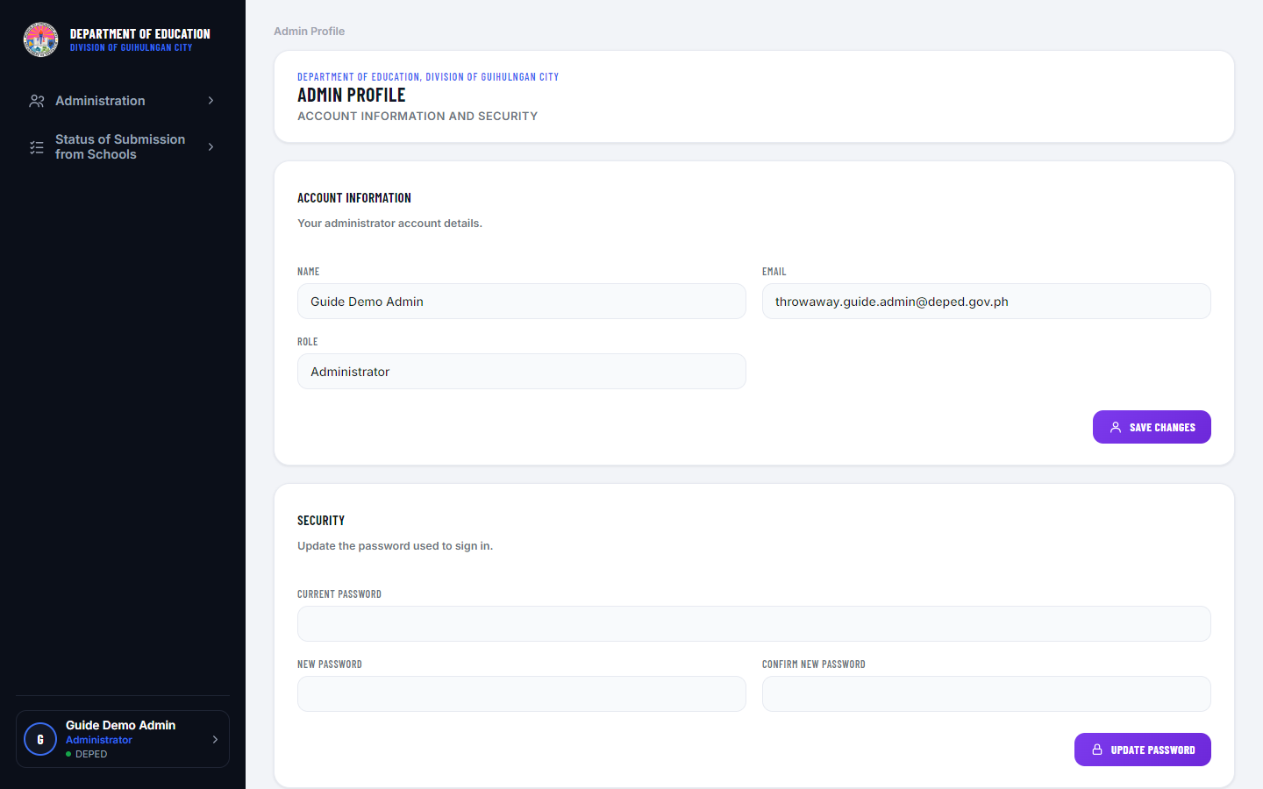
Figure 2.1 — Admin Profile page.

2.3 Setting the School Year and Term
1. From the sidebar, expand "Administration" and click "School Year & Term."
2. To add a new School Year, use the add form at the top — a new School Year automatically creates its three Terms (First, Second, Third).
3. Click "Set as Active" next to a School Year or a specific Term to make it the currently active period — schools can only upload files for the active School Year and Term.
4. To configure the submission schedule for a Term, click “Edit Submission Schedules” next to it. The form has a tab for each document type — Table of Specifications, Test Questionnaire, and LOA Result — each covering all 4 exam periods (Diagnostic Test, Summative Test 1, Summative Test 2, End of Term Exam) at once. Switch tabs to configure a different document type; each is configured independently.
5. Each document type tab has its own “Enforce Sequential Order” toggle, shown above its four Required checkboxes. When it’s on (the default), Required checkboxes for that document type must be turned on in order — Diagnostic Test, then Summative Test 1, then Summative Test 2, then End of Term Exam — and this only applies within that one document type; the other two tabs are unaffected. Turn the toggle off to mark any of the four Required in any order or combination instead. Unchecking a Required box is always allowed, regardless of the toggle.
6. Once a document type’s exam period is marked Required, its Start of Submission and Deadline fields become active — each now captures a specific date and time, not just a date. Set which file types schools may upload for it too (PDF, DOC, DOCX, XLS, XLSX — leave blank to accept any file type).
7. Turn on Allow Late Submission if schools should still be able to submit after the deadline passes. When on, a submission made past the deadline is accepted and recorded as “Late” instead of being blocked — the school sees a notice explaining this, and the file is flagged Late everywhere its status appears (Status of Submission, the stat cards, and the Status of Submission from Schools roster).
8. Click “Save Submission Schedules” to apply your changes.
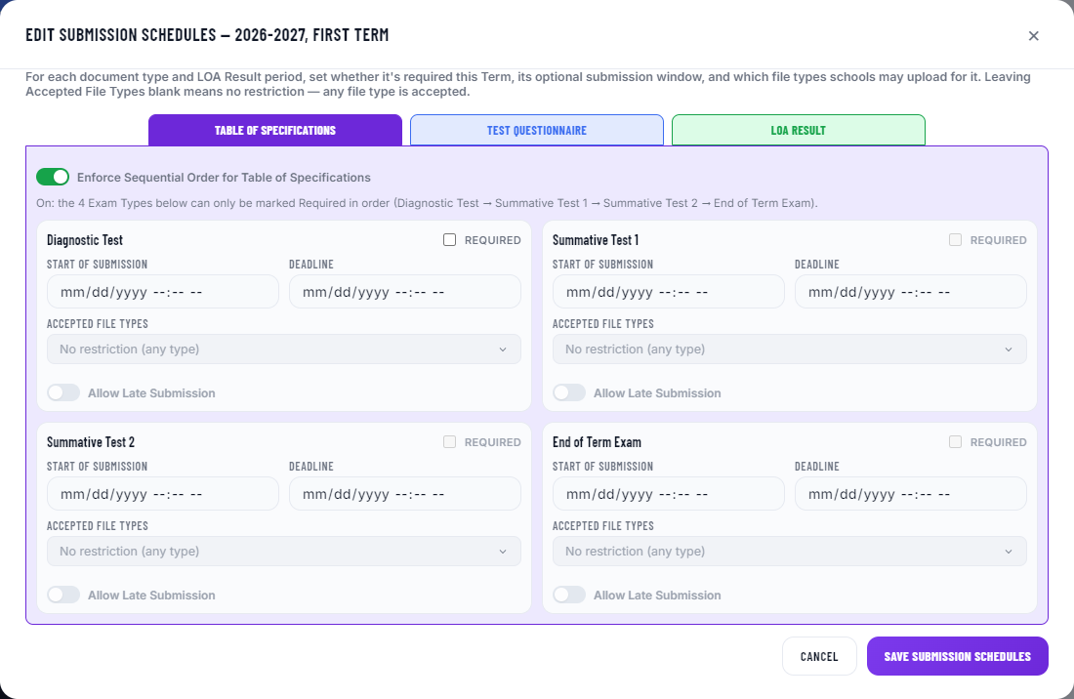
Figure 2.2 — Editing a Term’s submission schedule: the Table of Specifications / Test Questionnaire / LOA Result tabs, the Enforce Sequential Order toggle, date/time submission windows, in-order Required checkboxes, Accepted File Types, and Allow Late Submission.

2.4 Managing School Admins
1. Expand "Administration" and click "School Admin."
2. To create a new school, click “Create School Admin,” fill in the School ID Number, School Name, School Level, Cluster, Contact Name, School Email, and Account Password, then Save. The School Email doubles as that school’s login. You can also turn on Force Google Sign-In (for the School Admin account itself) and/or Force Google Sign-In for Grade Level Chairmen here, or leave both off and set them later from the table.
3. To add many schools at once, use “Bulk Upload (CSV)” — download the CSV template, fill it in, and upload it. Each row is processed independently, with a per-row success/failure result shown afterward. The template includes two optional columns, forceGoogleSignIn and forceChairmenGoogleSignIn — set either to true/yes/1 to turn that setting on for a row; leave blank for normal password access.
4. To edit a school, click the Edit icon on its row to open an edit form with its details.
5. To reset a school's password (e.g. if they're locked out), click the Reset Password icon on its row and enter a new password.
6. To remove a school entirely, use Delete — this also removes all of that school's grade levels, classes, submissions, and its Grade Level Chairman accounts, so use it carefully.
7. Each school’s row has two Force Google Sign-In toggles: “Force Google Sign-In (School Admin)” restricts that school’s own login to Google Sign-In only (its password is rejected); “Force Google Sign-In (Chairmen)” does the same for every Grade Level Chairman account under that school at once. Either can be switched on or off anytime directly from the table — it takes effect immediately, with no confirmation step and no separate save.
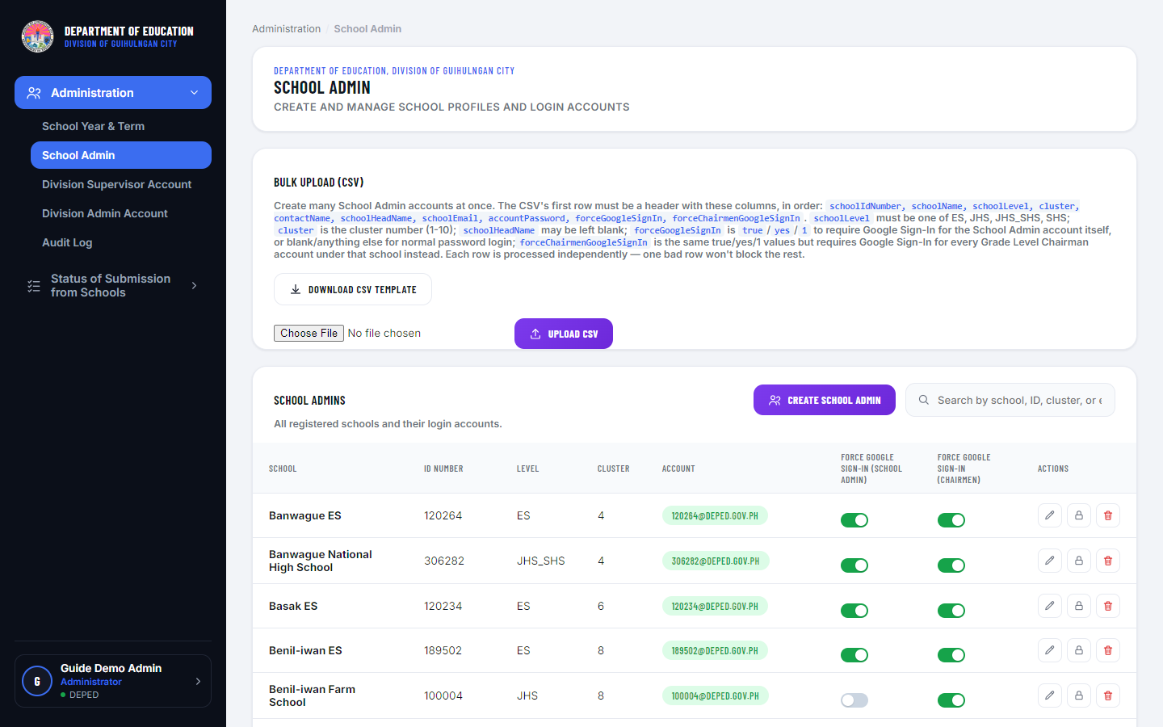
Figure 2.3 — School Admin management page, showing both Force Google Sign-In toggles.
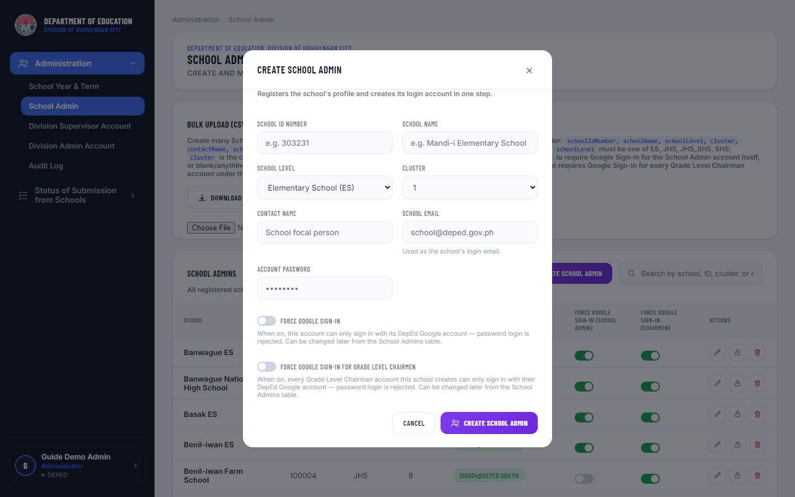
Figure 2.4 — Create School Admin form.

2.5 Managing Division Supervisor Accounts
1. Expand "Administration" and click "Division Supervisor Account."
2. Click "Create Supervisor Account," fill in the Supervisor's Name, DepEd Email, and Account Password, and check every Learning Area they should be able to view (grouped by ES/JHS Regular, JHS Electives, SHS Core, and SHS Cluster of Electives).
3. To add many supervisors at once, use "Bulk Upload (CSV)" at the top of the page — download the CSV template, fill it in (Assigned Learning Area(s) are semicolon-separated, e.g. "English;Science;STEM"), and upload it. Each row is processed independently.
4. To change a supervisor's assigned subjects later, click the Edit icon on their row, or remove a single subject directly from their row using the small remove button on that subject's chip.
5. Edit and Reset Password open a small form for that supervisor; Delete removes the account entirely.
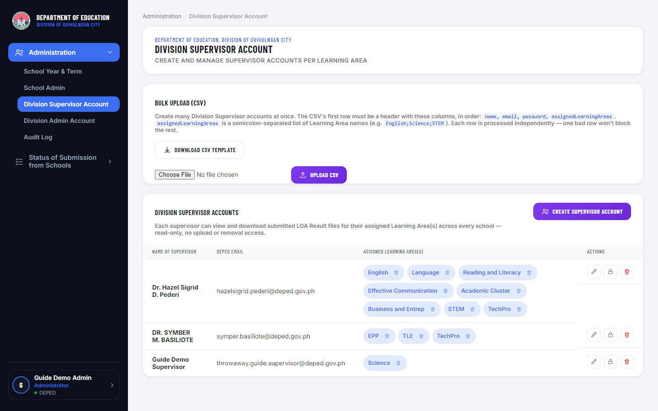
Figure 2.5 — Division Supervisor Account management page.
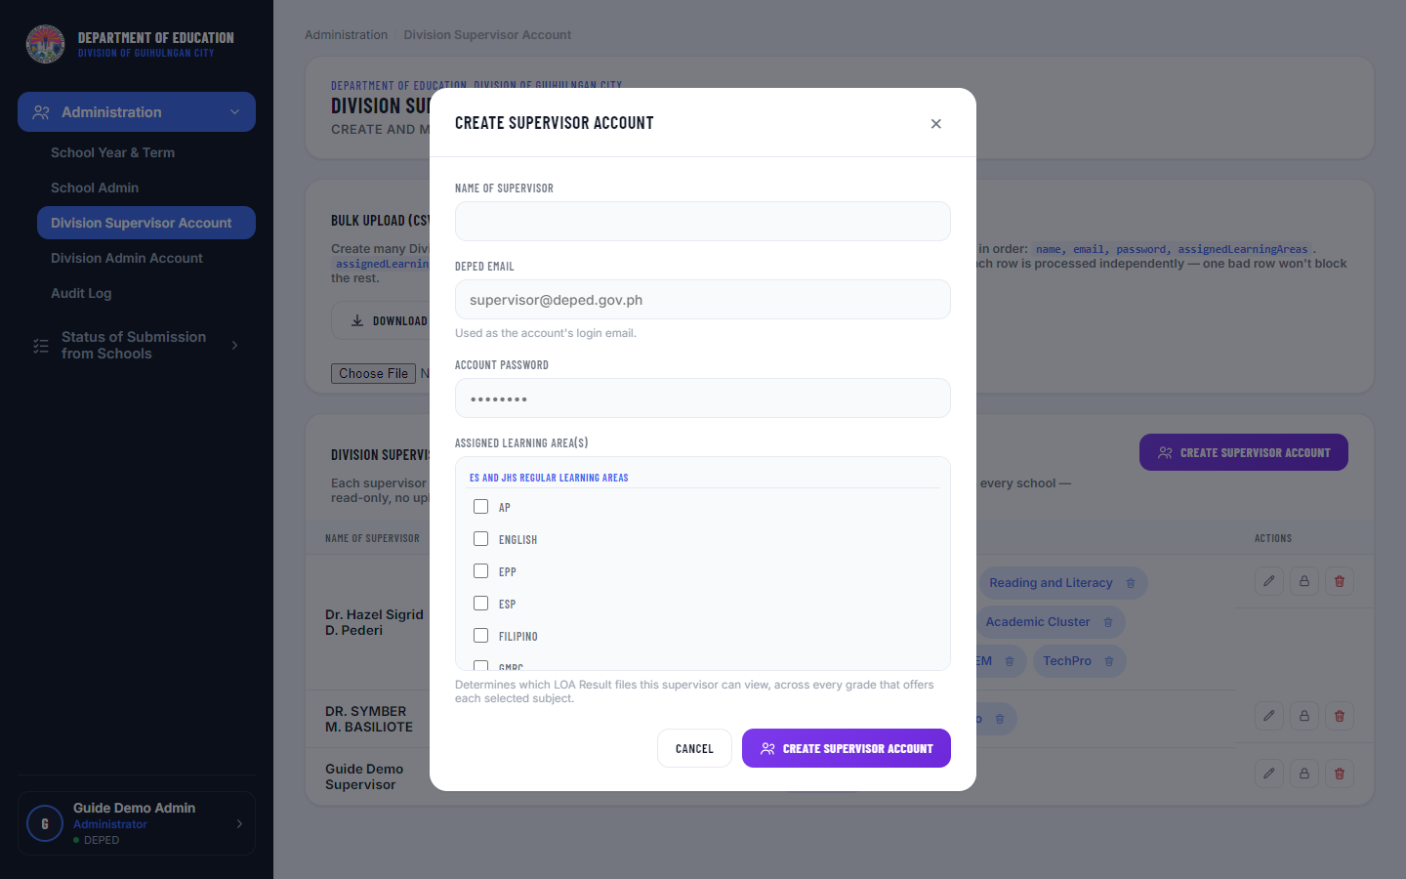
Figure 2.6 — Create Supervisor Account form.

2.6 Managing Division Admin Accounts
1. Expand "Administration" and click "Division Admin Account."
2. Click "Create Admin Account" to add another Division Admin.
3. Every admin (except yourself) can be edited or password-reset using the icon buttons on their row (each opens a small form), or deleted using the Delete icon. Your own row is labeled "You" and can only be managed from Admin Profile.
4. The system will not allow the last remaining Admin account to be deleted.
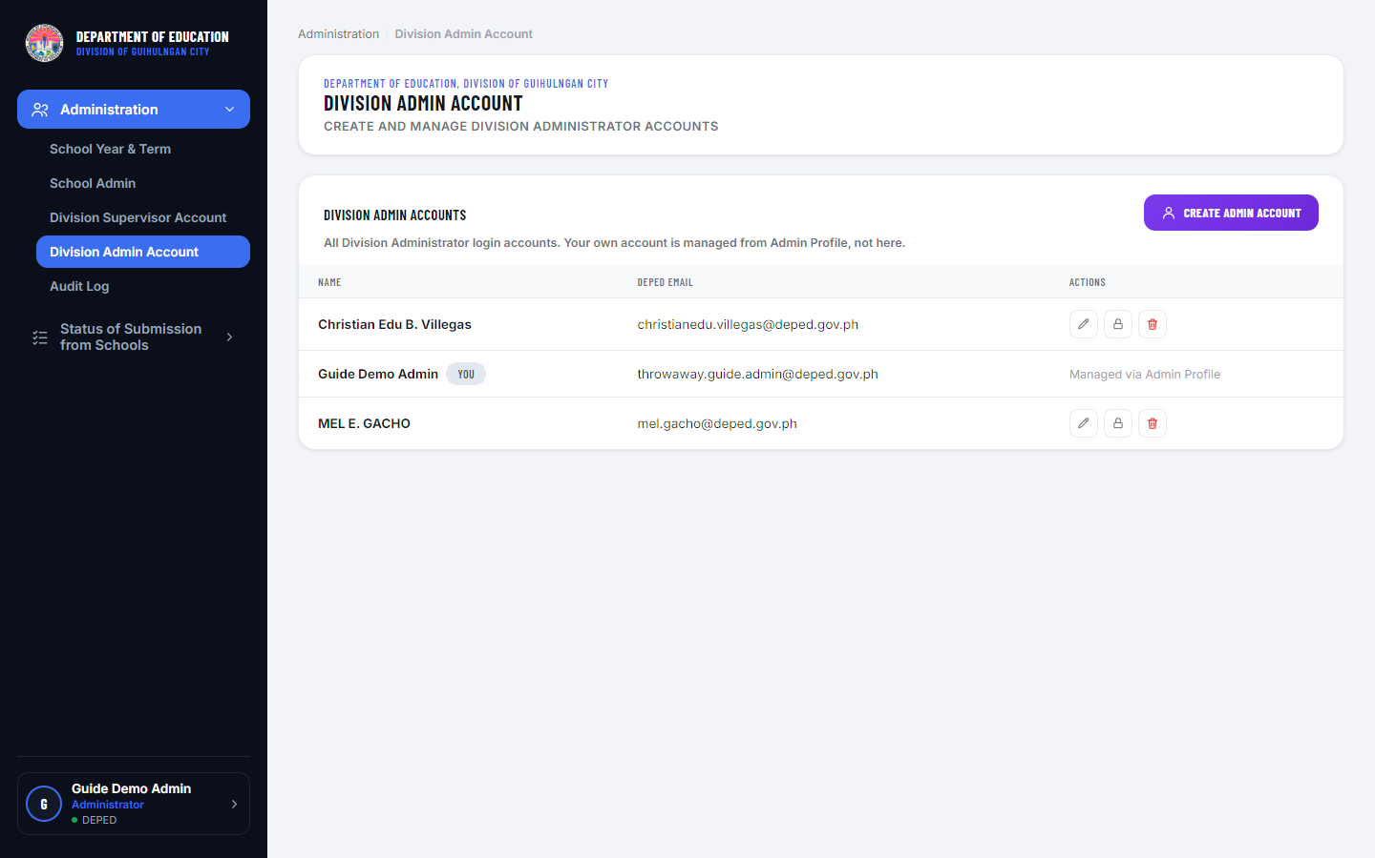
Figure 2.7 — Division Admin Account management page.

2.7 Reviewing the Audit Log
1. Expand "Administration" and click "Audit Log."
2. This page lists every security-sensitive action taken in the system: logins (successful and failed), account creation/editing/deletion/password resets across every role, and every LOA file upload, view, download, and removal.
3. Use the Action, Actor Role, date range, and search filters to narrow the list, then click "Apply Filters."
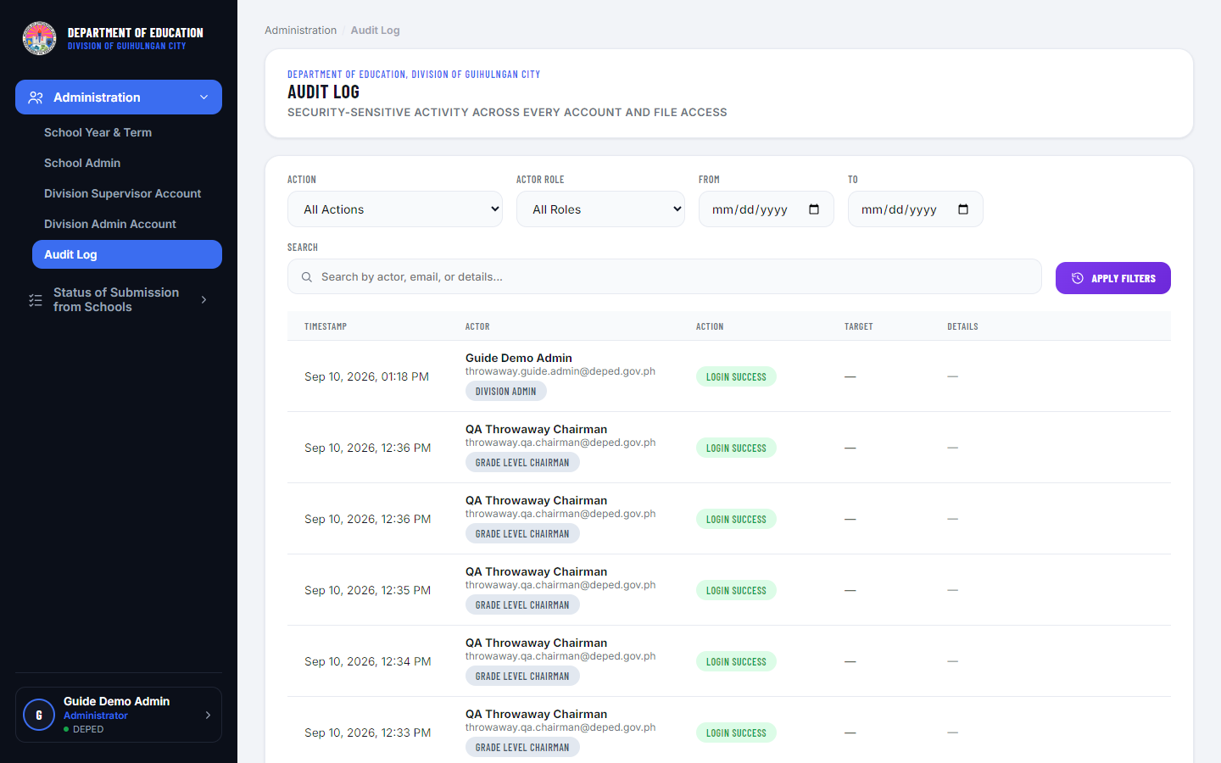
Figure 2.8 — Audit Log page.

2.8 Monitoring Status of Submission from Schools
1. In the sidebar, expand “Status of Submission from Schools” and click the document type you want to review — Table of Specifications, Test Questionnaire, or LOA Result.
2. The stat cards at the top show division-wide (or filtered) Submitted/Late/Not Submitted counts.
3. Use the Cluster, School, School Year, Term, Exam Type, Timeliness, and Status filters to narrow the view.
4. Leaving School set to "All Schools" shows a roster — one row per school, with a summary of each school's submissions per grade level.
5. Selecting a specific School switches to a detailed drill-down: one collapsible section per Grade Level, showing every Class/Section against every Learning Area, with a status pill per cell. Click a filled cell’s View action to preview the file in a window (a Download button is always available there too, even for file types — or browser settings — that can’t show a preview), or Download to save it directly.
6. The Timeliness filter narrows results to On Time Submission or Late Submission only; the Status filter narrows to Complete Submission (every applicable subject filled) or Incomplete Submission. Both apply to the roster and to the single-school drill-down.
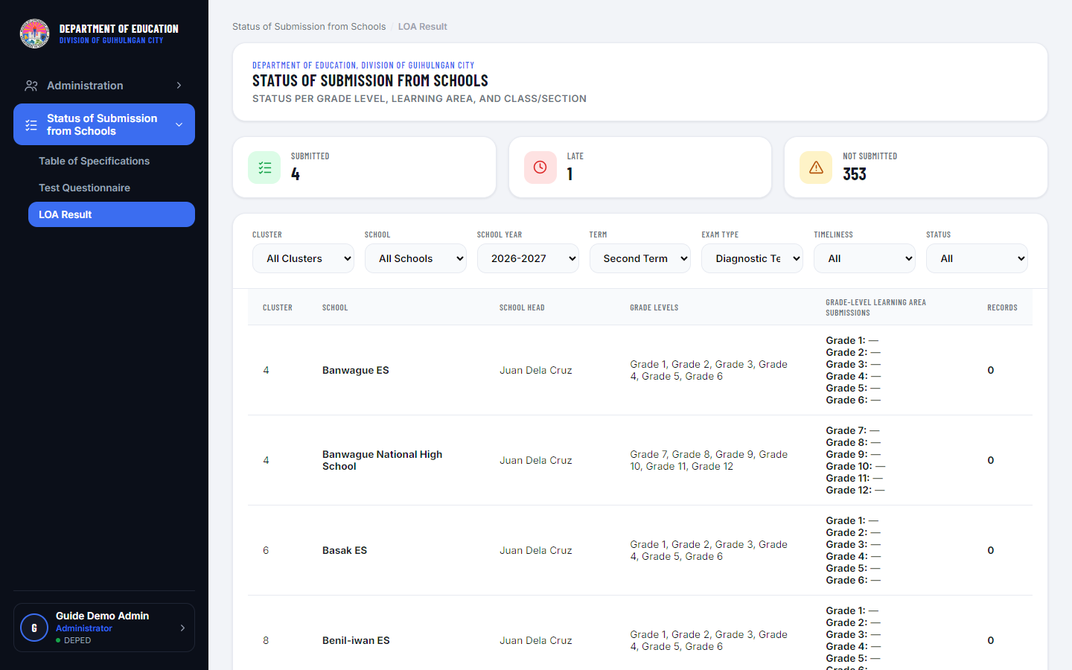
Figure 2.9 — Status of Submission, multi-school roster view, with the Timeliness and Status filters.
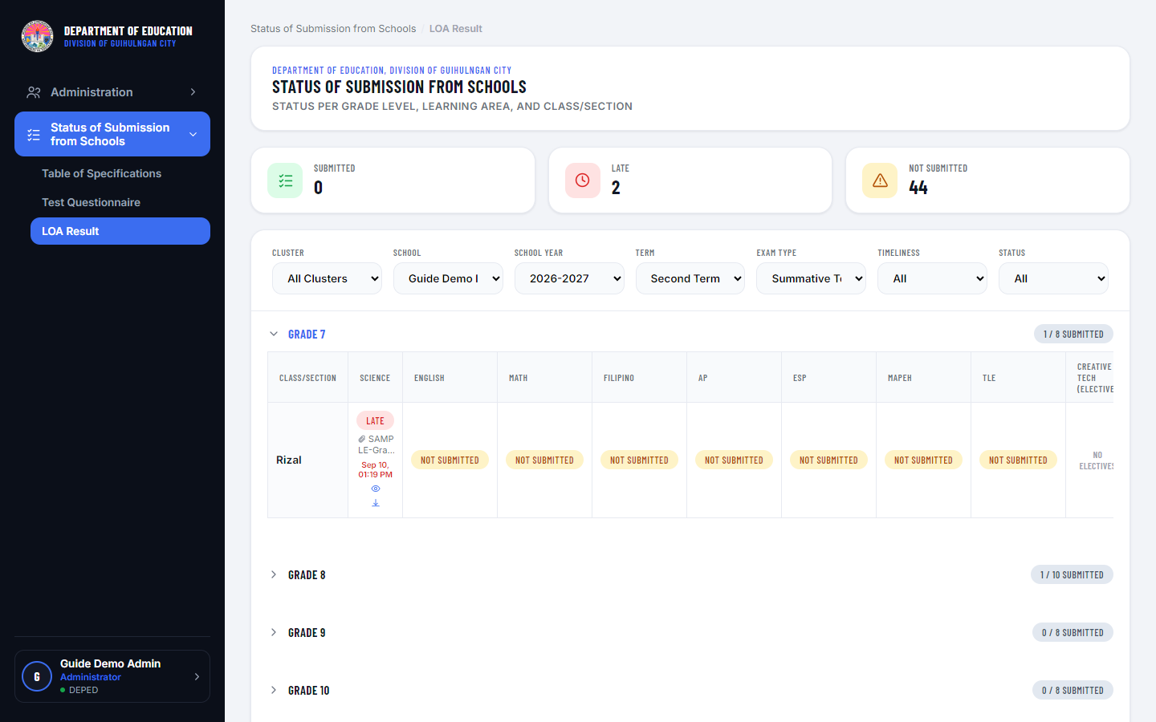
Figure 2.10 — Status of Submission, single-school drill-down view.

3. School Admin

3.1 Role and Responsibilities
The School Admin is the single official login for a school (usually held by the school head or a designated administrative staff member). A School Admin is responsible for:
- Keeping the school's profile information current
- Organizing the school's classes/sections per grade level
- Creating Grade Level Chairman sub-accounts and delegating grade-level upload responsibility to them if desired
- Uploading submission files (LOA Result, Test Questionnaire, Table of Specifications) for every Learning Area, Class/Section, Term, and Exam Type
- Monitoring the school's own submission status

3.2 School Profile
1. Click "School Profile" in the sidebar.
2. Under Basic Information, edit your School Head Name and School Email (this doubles as your login) and click Save.
3. Under Security, change your account password (current password required). If a Division Admin has turned on Force Google Sign-In for your account, this form is replaced with a message instead — your account can only sign in with Google, so there is no password to change.
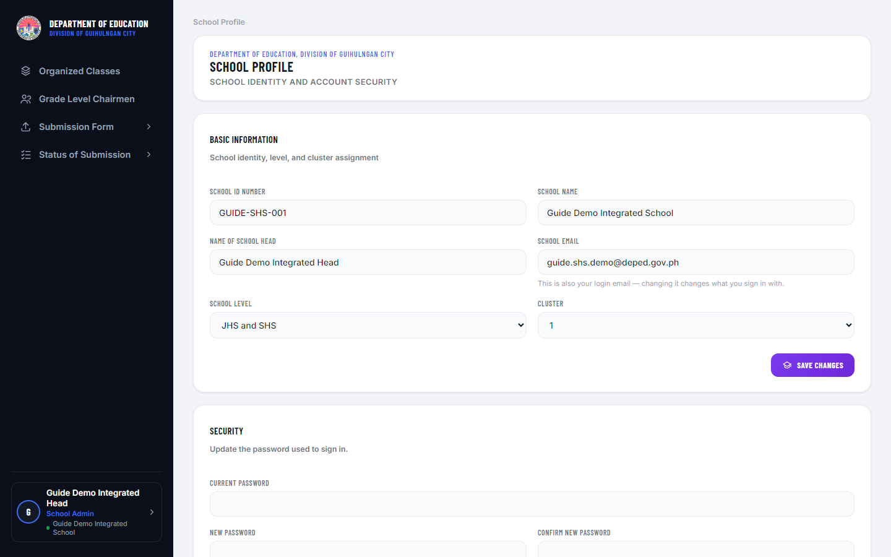
Figure 3.1 — School Profile page.

3.3 Organized Classes
1. Click "Organized Classes" in the sidebar.
2. For each Grade Level, use "Add Class(es)" to add one or more Class/Sections (e.g. "1", "2", "Rizal", "Bonifacio" — any name you choose).
3. For Grade 7-10 classes, use the dropdown on a class chip to toggle whether it has "Electives" enabled (this controls whether Creative Tech/Research uploads are allowed for that class).
4. For Grade 11-12 schools, a second table, "Cluster of Electives — File Limit Per Class," lets you set how many files each class/section can upload for each of the four Cluster of Electives subjects (Academic Cluster, Business and Entrep, STEM, TechPro).
5. To remove a class/section, use its chip's delete button.
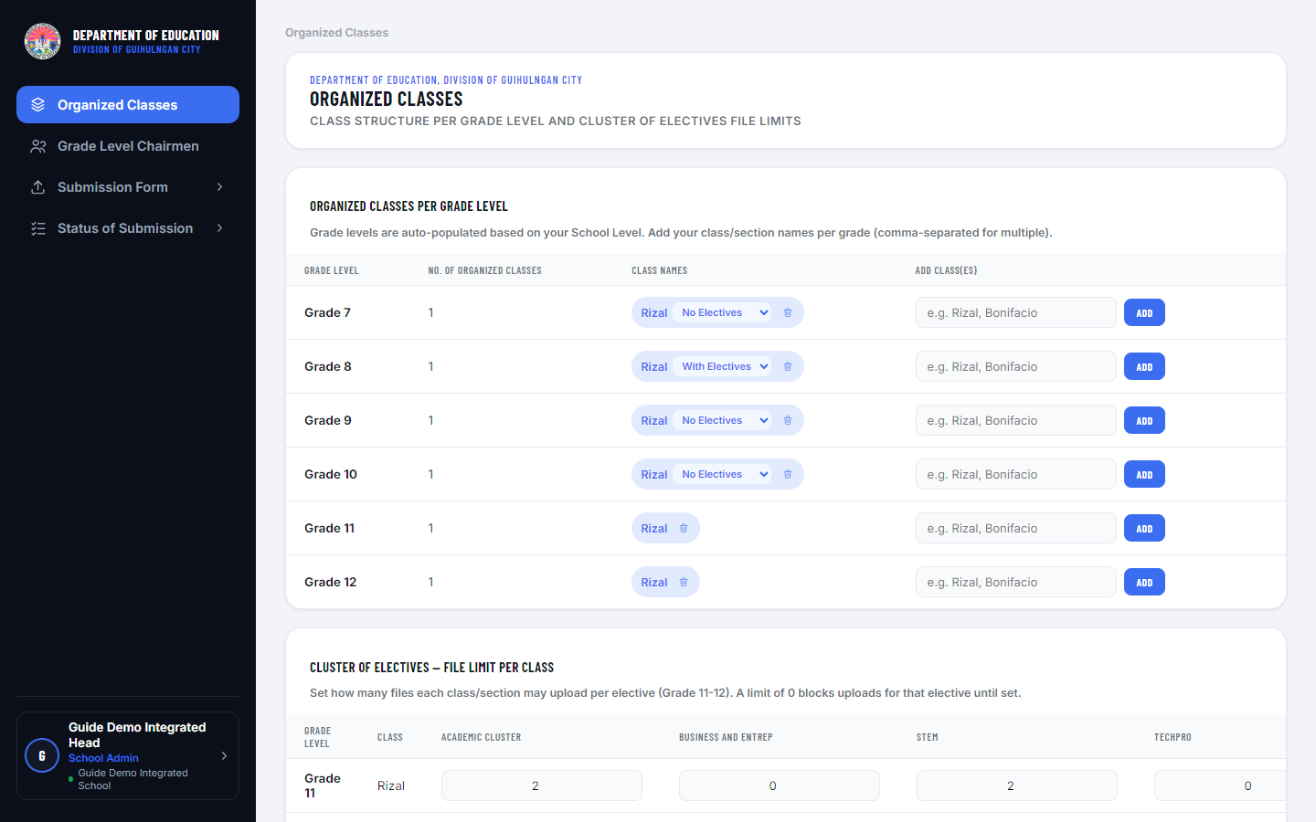
Figure 3.2 — Organized Classes page.

3.4 Grade Level Chairmen
1. Click "Grade Level Chairmen" in the sidebar.
2. Click "Add Chairman Account," fill in their Name, Email, and Password. For most schools, also pick the single Grade Level they’ll be responsible for, then Save.
3. For an Elementary school (ES) only, a Multigrade toggle appears in this form. Turn it on if one Chairman will cover more than one grade level — the single Grade Level dropdown is replaced with a checklist of every grade in the school; check every grade this Chairman should be responsible for, then Save. Turning Multigrade back off keeps only the first grade you had checked.
4. Existing chairmen can be edited or password-reset using the icon buttons on their row (each opens a small form), or removed using the Delete icon. A Multigrade chairman’s row lists all of their assigned grades and shows a “Multigrade” label, so they’re easy to tell apart from a regular, single-grade chairman.
5. A Grade Level Chairman account can only upload files and view status for the grade level(s) they’re assigned to — they have no access to School Profile or to managing other chairmen.
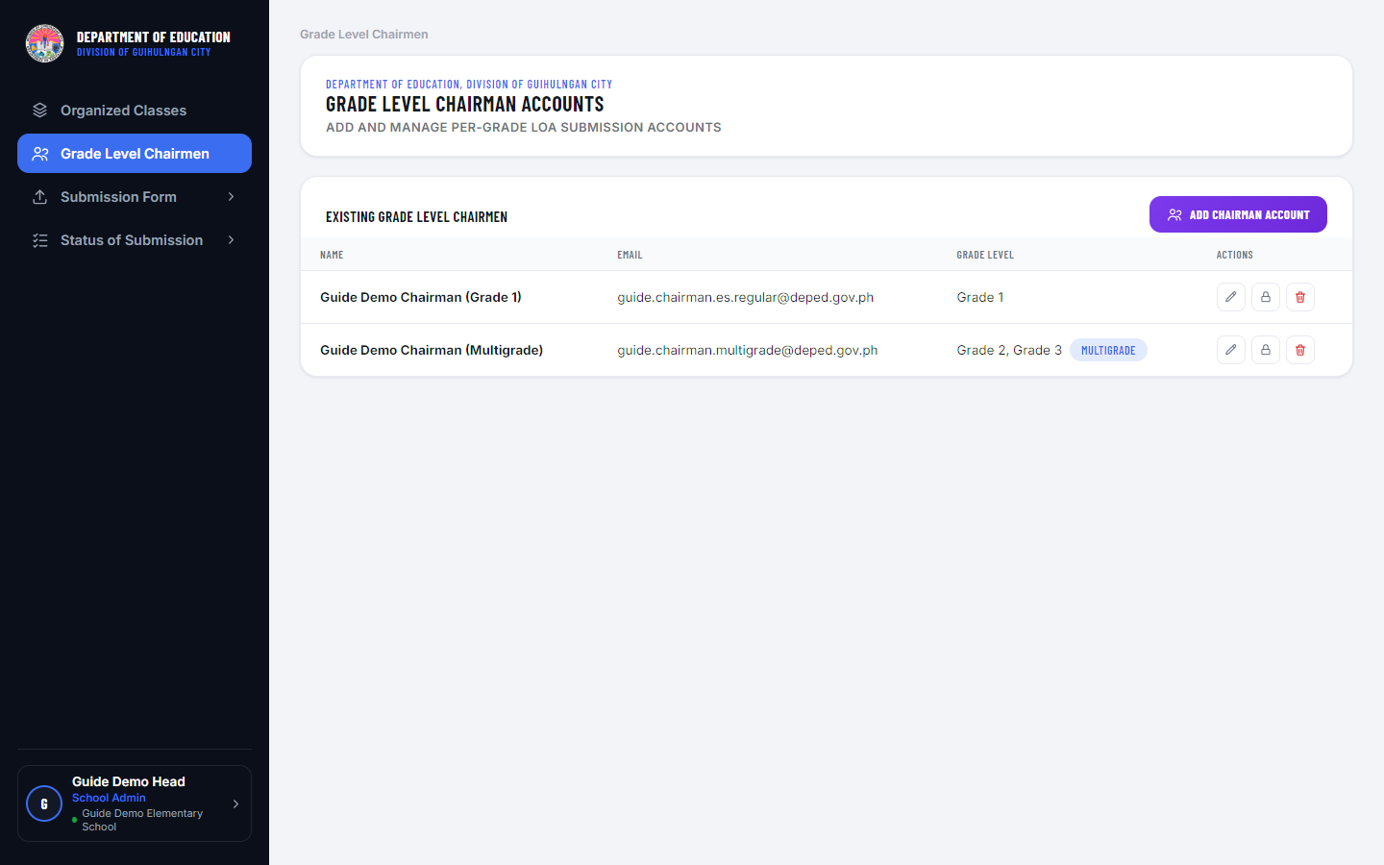
Figure 3.3 — Grade Level Chairmen management page, contrasting a regular (single-grade) chairman with a Multigrade chairman.
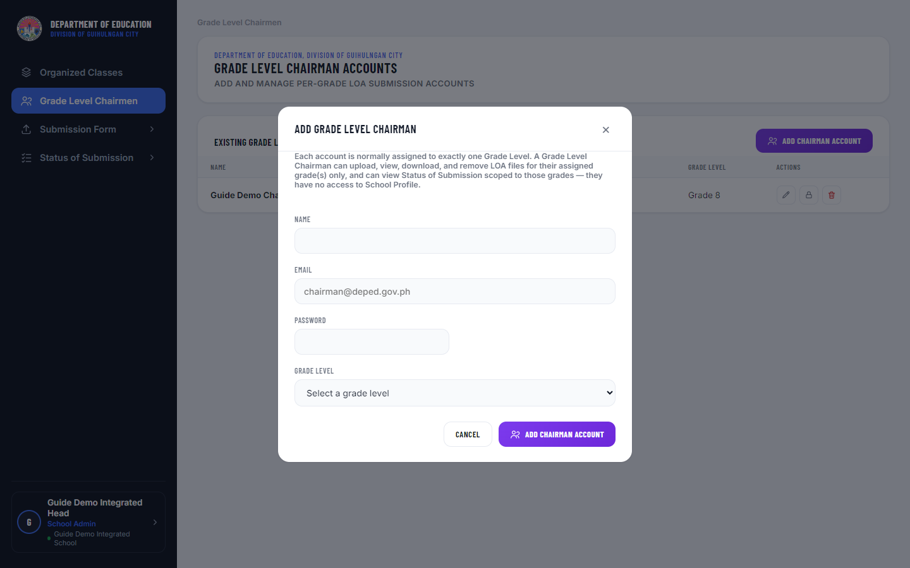
Figure 3.4 — Add Chairman Account form on a non-ES school (no Multigrade option appears).
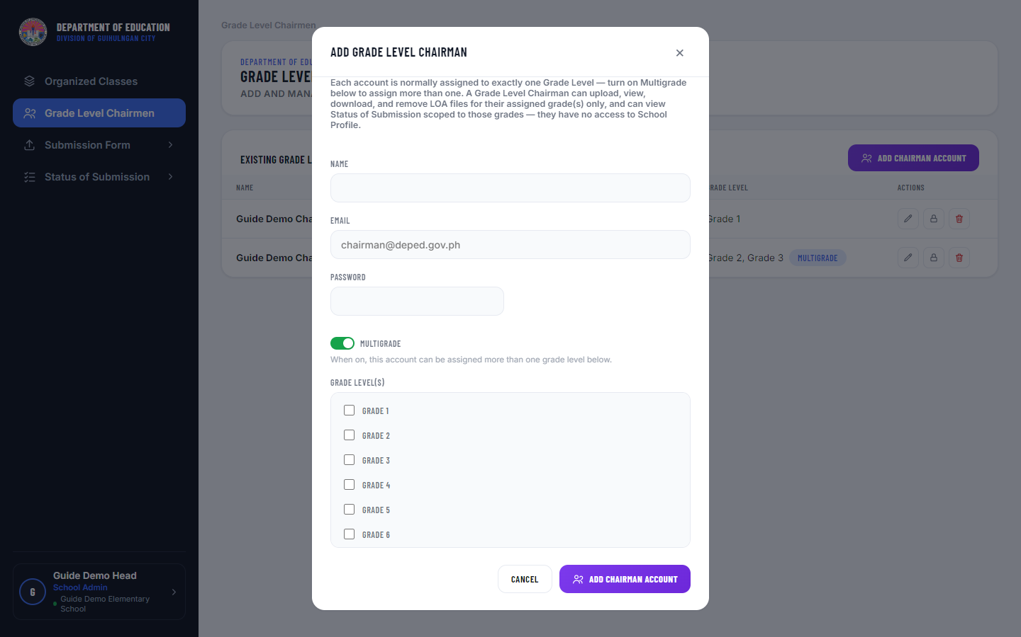
Figure 3.5 — Add Chairman Account form on an ES school, with Multigrade turned on and the grade checklist shown.

3.5 Submission Form
1. In the sidebar, expand “Submission Form” and click the document type you want to work in — Table of Specifications, Test Questionnaire, or LOA Result.
2. Select the School Year, Term, Grade Level, and Exam Type (one of the four exam periods) you want to work in.
3. The page shows a matrix — every Class/Section as a row, every Learning Area as a column (Grade 11-12 additionally splits into "Core Subjects" and "Cluster of Electives" sections).
4. Click an empty cell's upload box to upload that class's file for that subject. Once uploaded, the cell shows View, Download, and Remove actions.
5. Uploading and removing files is only allowed for the currently active School Year/Term, and only within the selected Exam Type/Document Type’s configured submission window (if the Admin has set one) — cells outside that window are shown disabled with an explanation. If the Admin has turned on Allow Late Submission for that combination, you can still upload after the deadline; an amber notice explains this, and the file is recorded (and shown) as “Late” rather than being blocked.
6. For Grade 11-12 Cluster of Electives subjects, a cell accepts multiple files up to the target your school set in Organized Classes — the cell shows a running count (e.g. "1 / 2 files") and an "Add file" control while under target.
7. A file’s upload timestamp is shown below its name — it turns red when the file was submitted after the deadline (Late), so you can see at a glance which files were on time.
8. Click View on an uploaded file to preview it in a window. PDF files preview inline; other file types (and PDFs, if your browser is set to download them instead of opening them) show a “Preview isn’t available” message instead — either way, a Download button is always available in the same window.
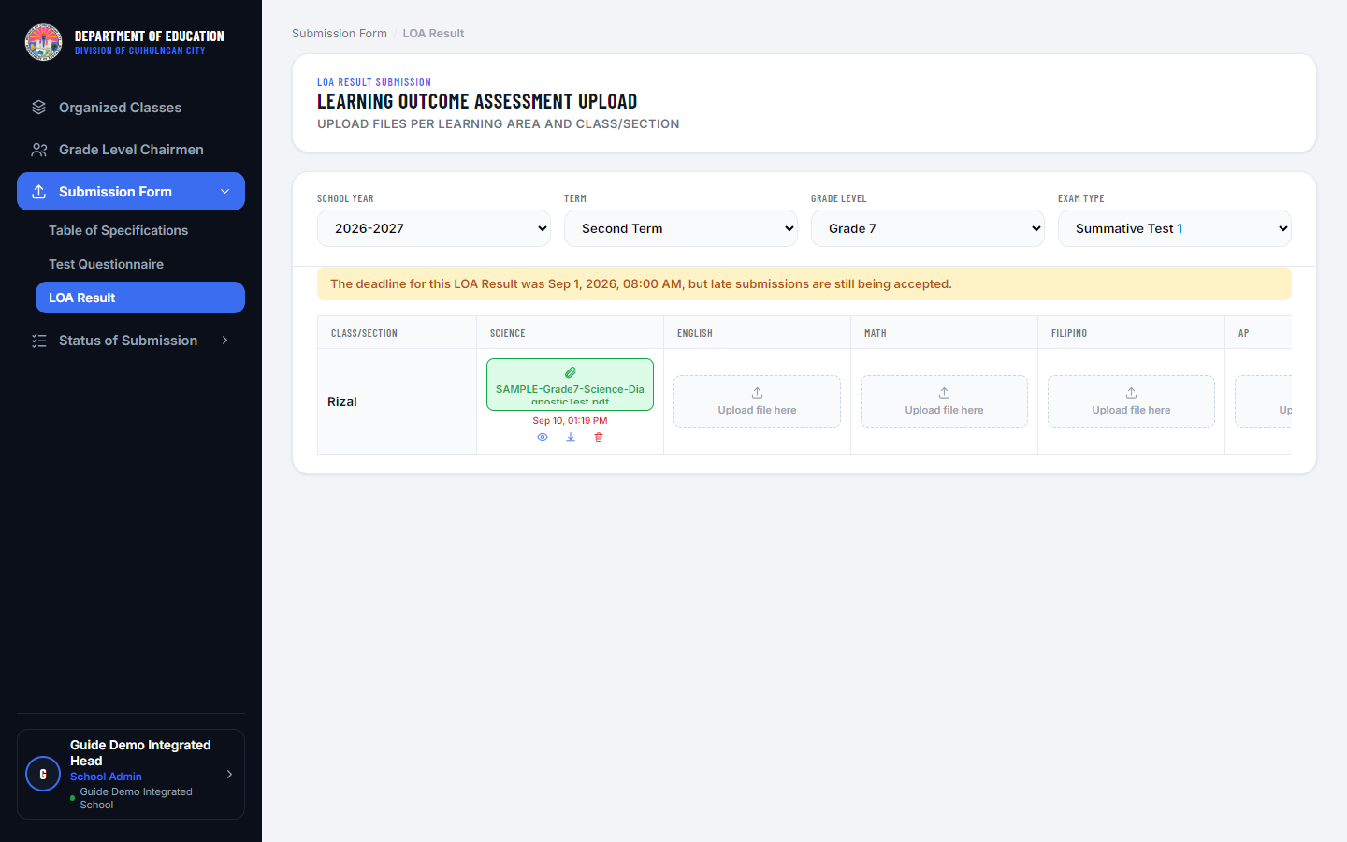
Figure 3.6 — Submission Form page, showing the late-submission notice and a red “Late” timestamp.
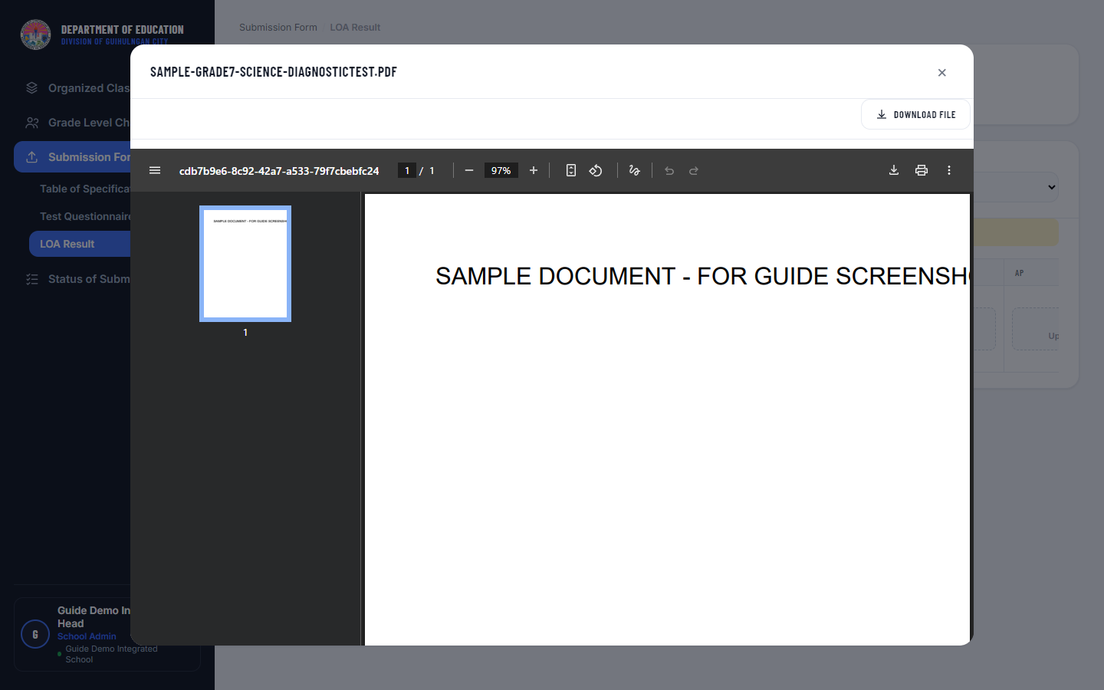
Figure 3.7 — The file preview window. A Download button is always shown, whether or not the file can be previewed inline.

3.6 Status of Submission
1. Click "Status of Submission" in the sidebar.
2. The stat cards show your school’s Submitted/Late/Not Submitted counts for the selected Term/Exam Type/Document Type.
3. Below, one collapsible section per Grade Level shows every Class/Section against every Learning Area with a status pill — the “Remarks” column marks a class/section “Complete Submission” once every applicable subject is filled (a Late submission still counts as filled). The stat cards and status pills distinguish Late (submitted after the deadline, shown in red) from Submitted (on time).
4. Filled cells have View and Download actions, same as Submission Form — but this page is read-only otherwise (no uploading here). A Late file’s timestamp is shown in red, same as on the Submission Form page.
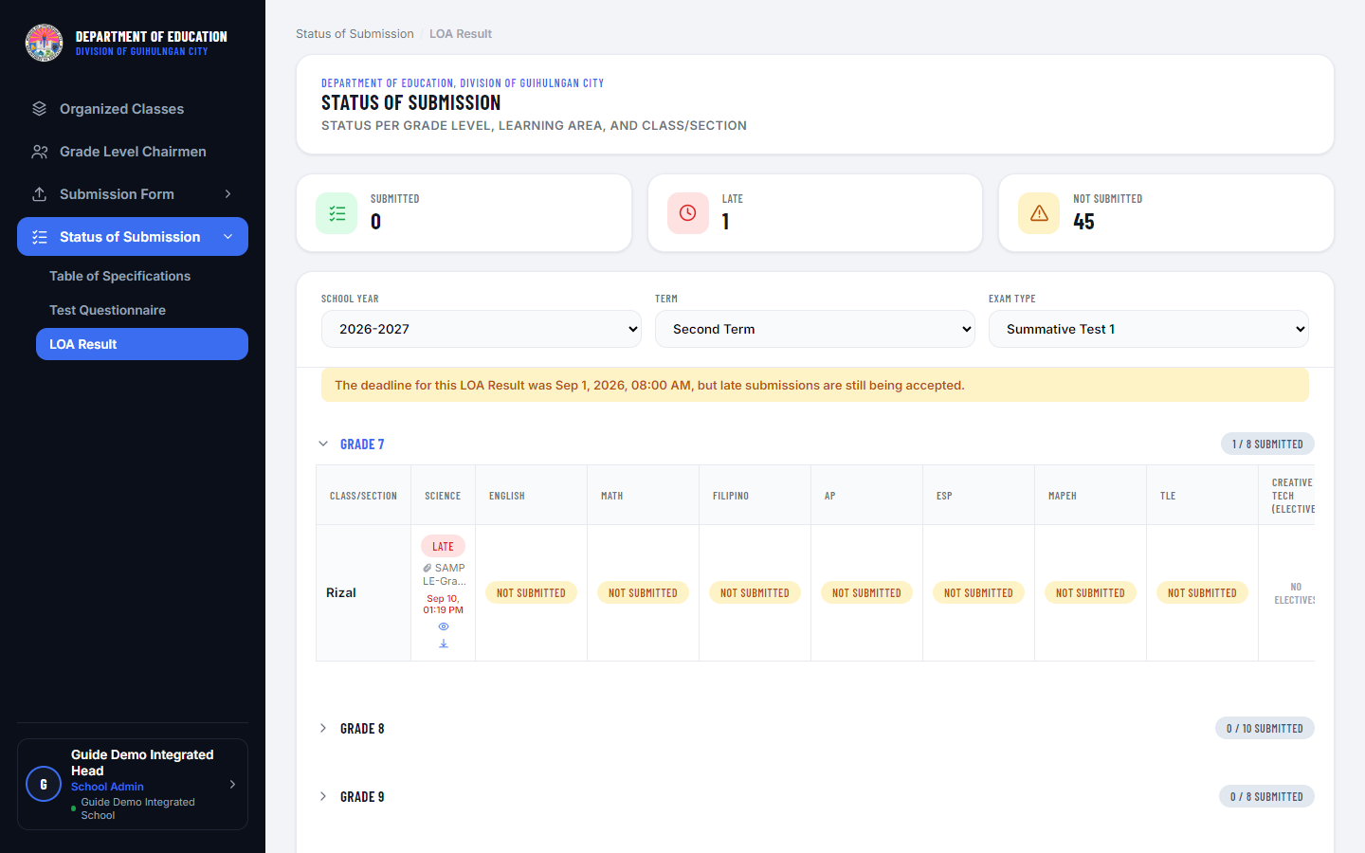
Figure 3.8 — Status of Submission page, showing a red “Late” status pill and timestamp.

4. Grade Level Chairman

4.1 Role and Responsibilities
A Grade Level Chairman is a sub-account created by a School Admin, scoped to exactly one grade level. A Chairman's responsibilities mirror a School Admin's, but narrowed to their one assigned grade:
- Uploading submission files for their grade level’s Classes/Sections
- Monitoring submission status for their grade level
A Chairman has no access to School Profile, Organized Classes, or managing other Chairman accounts — those remain the School Admin's responsibility.

4.2 Chairman Profile
1. Click your avatar and select "Grade Level Chairman Profile."
2. Edit your Name/Email under Account Information, or change your password under Security. Your Role field shows which grade(s) you're assigned to (e.g., "Grade Level Chairman — Grade 7", or "Grade Level Chairman — Grade 2, Grade 3" if you are a Multigrade Chairman). If your school's Division Admin has turned on Force Google Sign-In for Grade Level Chairmen, the Security section is replaced with a message instead — your account can only sign in with Google.
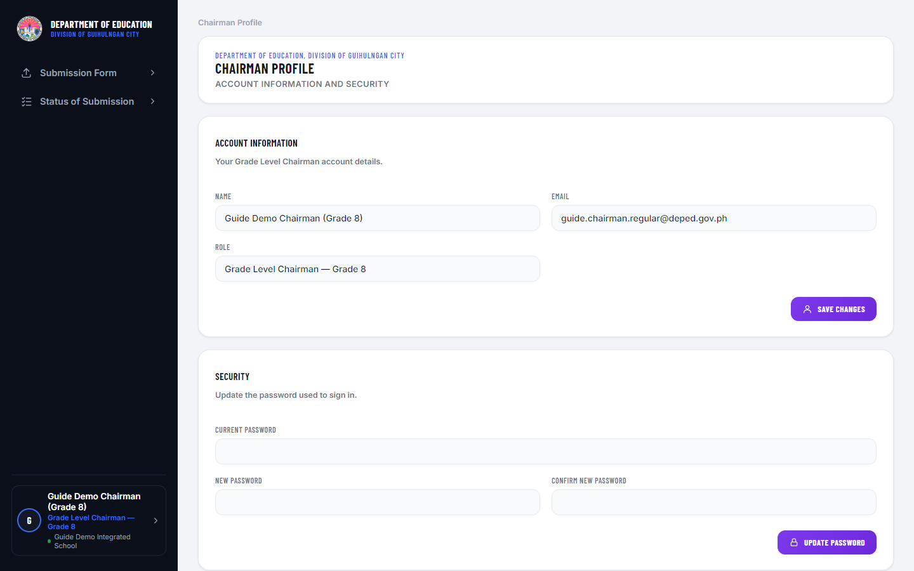
Figure 4.1 — Chairman Profile page.

4.3 Submission Form
1. In the sidebar, expand “Submission Form” and click the document type you want to work in — Table of Specifications, Test Questionnaire, or LOA Result. The Grade Level filter is locked to your assigned grade(s): shown disabled with a single grade if you have only one (the usual case), or as a dropdown limited to just your assigned grades if you are a Multigrade Chairman covering more than one.
2. Select the School Year, Term, and Exam Type, then upload files into the matrix exactly as a School Admin would — the same rules apply (active Term, submission window, Cluster of Electives targets).
3. The same submission-window, late-submission, red-timestamp, and file-preview behaviors described for School Admins in Section 3.5 apply here.
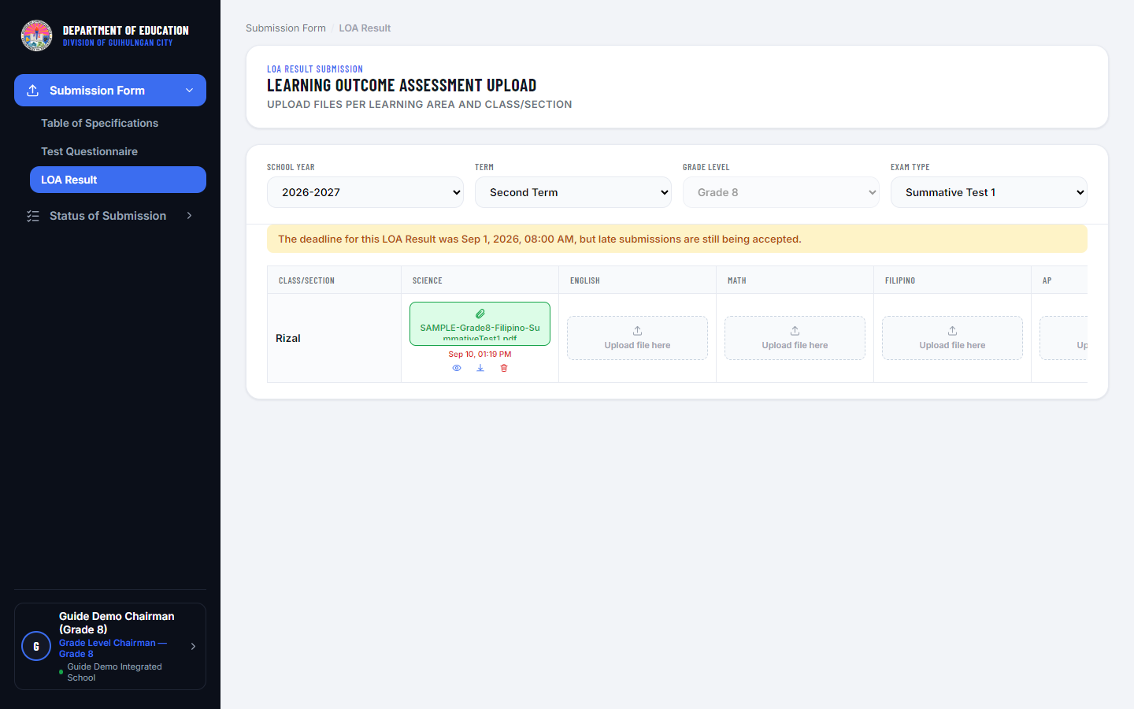
Figure 4.2 — Submission Form page, grade-locked to the Chairman’s assigned grade.

4.4 Status of Submission
1. Click "Status of Submission" — this is automatically scoped to your one grade level; no filter is needed.
2. Late submissions and their red indicators work the same way as described for School Admins in Section 3.6.
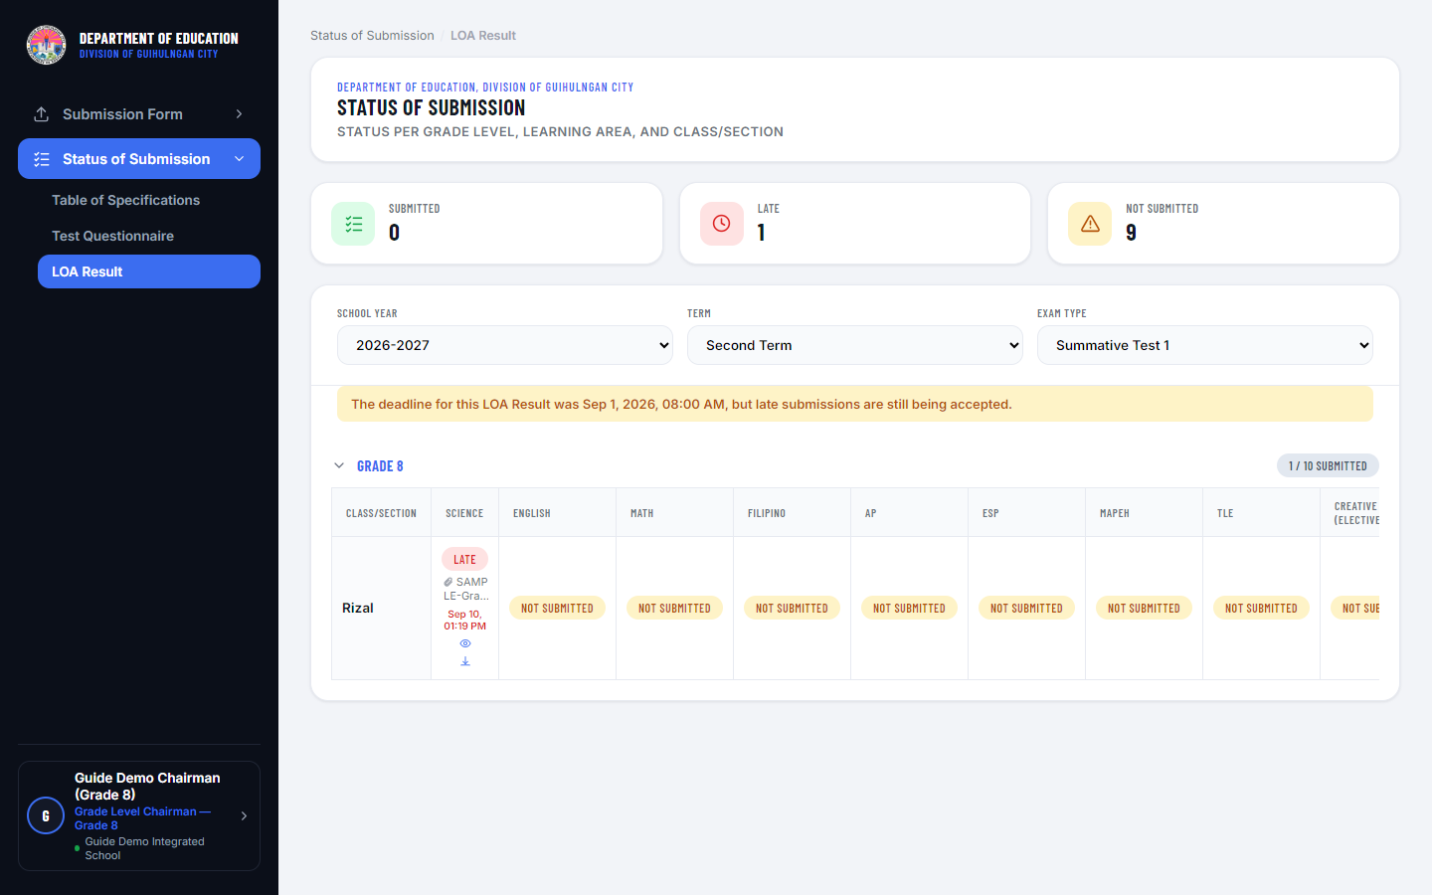
Figure 4.3 — Status of Submission page, grade-locked.

5. Division Supervisor

5.1 Role and Responsibilities
A Division Supervisor is a division-wide, read-only reviewer scoped by subject (Learning Area) rather than by school. A Supervisor's role is to:
- View and download every submitted submission file (LOA Result, Test Questionnaire, Table of Specifications), across every school in the division, for whichever Learning Area(s) they are assigned
Supervisors cannot upload or remove files, and have no access to any school-management page — their account is created and their subject assignment is managed entirely by a Division Admin.

5.2 Supervisor Profile
1. Click your avatar and select "Division Supervisor Profile."
2. Edit your Name/Email or change your password. Your Assigned Learning Area(s) are shown but can only be changed by a Division Admin.
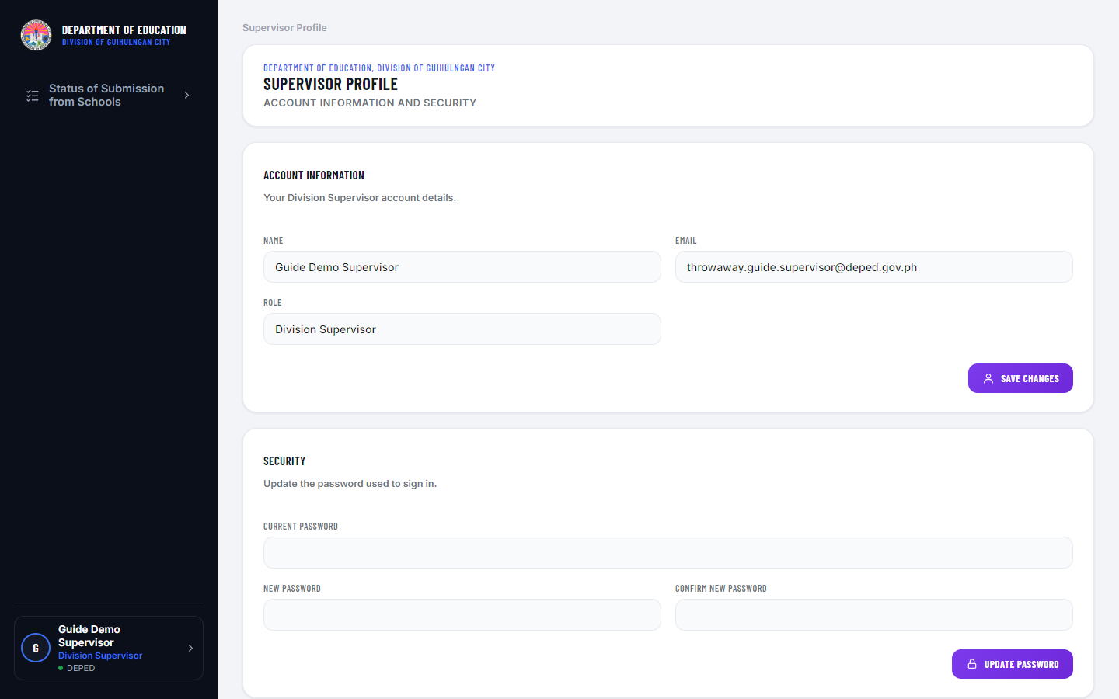
Figure 5.1 — Supervisor Profile page.

5.3 Status of Submission from Schools
1. In the sidebar, expand “Status of Submission from Schools” and click the document type you want to review — Table of Specifications, Test Questionnaire, or LOA Result.
2. Use the Cluster, School, School Year, Term, Exam Type, and Learning Area filters to narrow the list — Learning Area defaults to “All Assigned Areas,” showing every subject you are assigned across every school.
3. The table lists every matching file: School, Grade Level, Class/Section, Learning Area, File name, and Status. Status is Submitted (on time) or Late (submitted after its deadline, if the school’s Admin allows late submissions for that Exam Type/Document Type).
4. Click View to preview the file in a window — PDF files preview inline, and a Download button is always available there too (for file types a browser cannot preview, or if your browser is set to download PDFs automatically). Click Download to save the file directly without opening the preview.
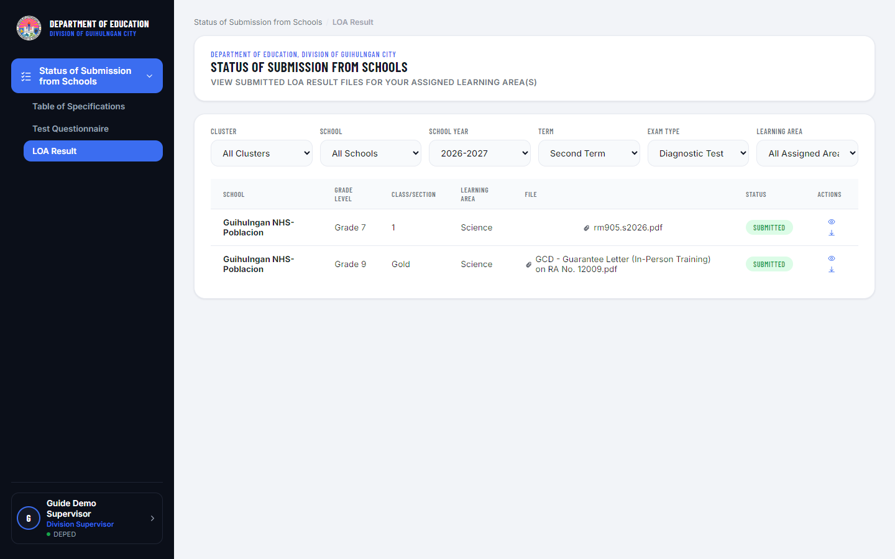
Figure 5.2 — Status of Submission from Schools page.

6. Quick Reference: Who Can Do What
Task | Admin | School | Chairman | Supervisor
Upload submission files | No | Yes (own school) | Yes (own grade only) | No
View / Download submission files | Yes (any school) | Yes (own school) | Yes (own grade only) | Yes (assigned subjects, any school)
Manage School Admins | Yes | — | — | —
Manage Grade Level Chairmen | — | Yes (own school) | — | —
Manage Supervisor Accounts | Yes | — | — | —
Manage Admin Accounts | Yes | — | — | —
Configure School Year / Term / Schedule | Yes | — | — | —
View Audit Log | Yes | — | — | —
Edit School Profile | — | Yes | — | —

